***DUAL BOOT EXERCISES***

**EXERCISE 1 → INSTALLATION AND CONFIGURATION OF WINDOWS 7 AND 10**

For this exercise we will need a new virtual machine, so the examples shown in this exercise will be from the machine used for the GParted exercises, which we will recycle, but you are totally free to create a new one. The only “must” we have is the creation of a hard drive with partitions (in which we will install the different operating systems).

**We will skip the installation steps, as we did specific exercises on the topic.

After the installation of Windows 7 we have to go to “Storage” and change the ISO file of Windows 7 to Windows 10. It is also recommended to go to “System” and make some configurations (to avoid failures at the time of starting the installation) just as the ones below:

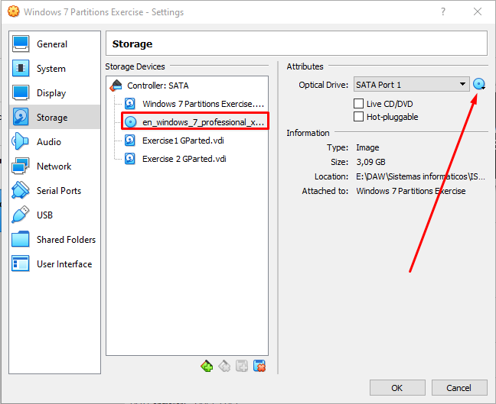

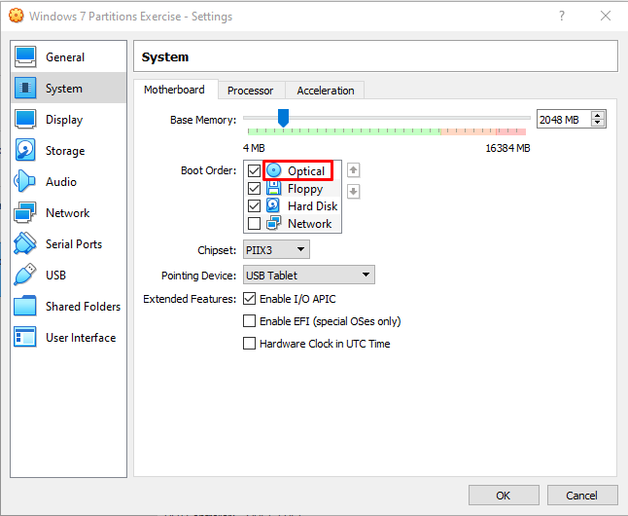

As we said, we will need to have partitions in our hard drive. In this case, we will install our OS in our 40GB partition:

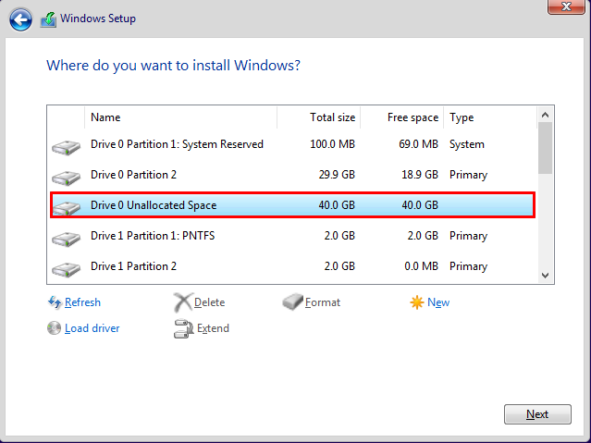

After the installation, its bootloader will appear. What we recommend now is to choose Windows 10, complete its initial configurations and then change the settings asked in this exercise.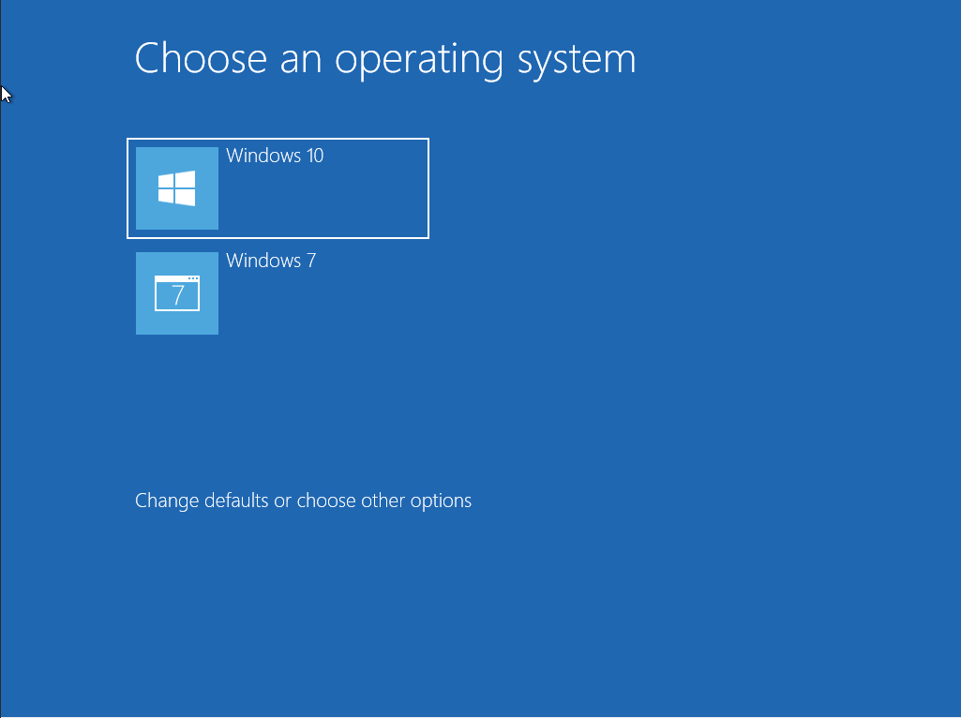

(INITIAL CONFIGURATIONS...)

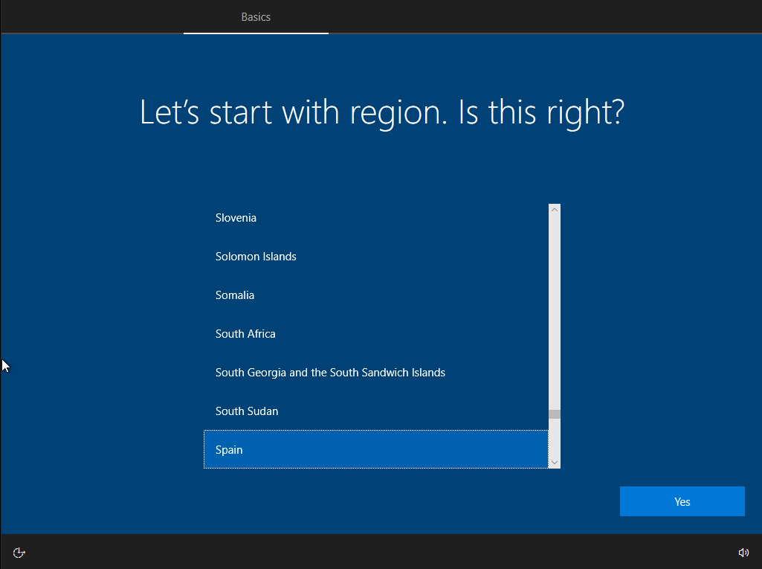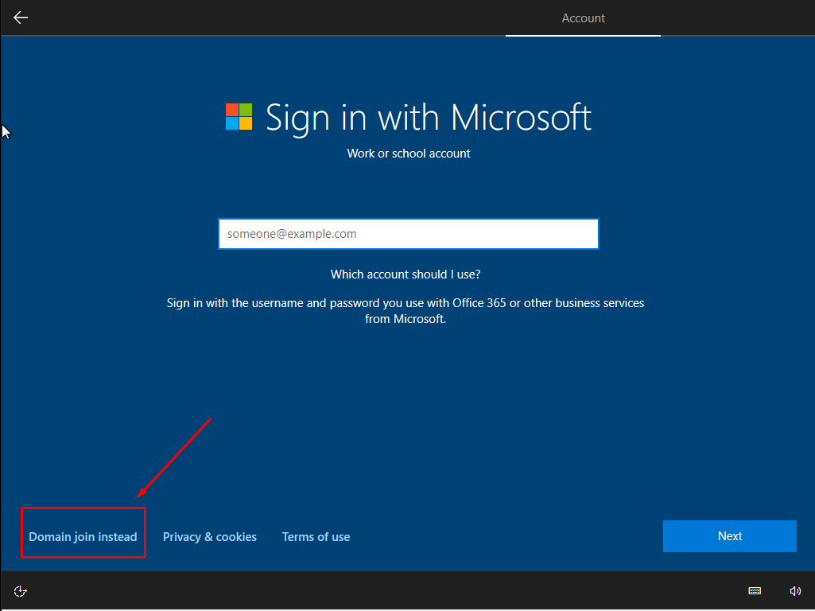

etc…

Once these configurations are finished, we will go to the Windows menu, click on the configuration icon, click “Update & Security”.

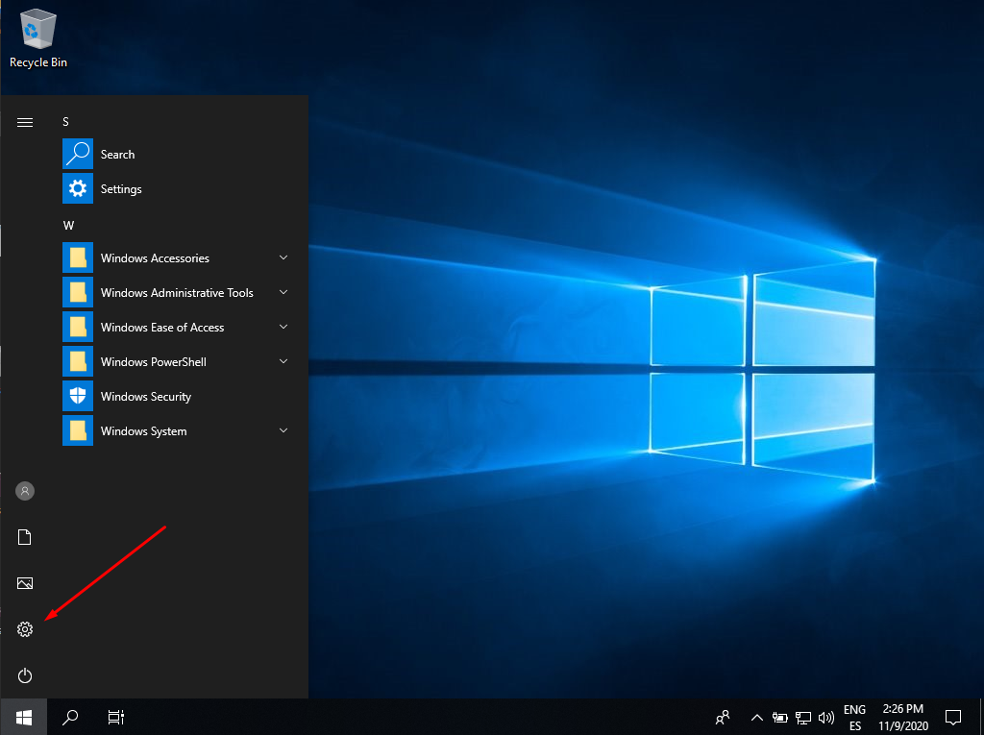

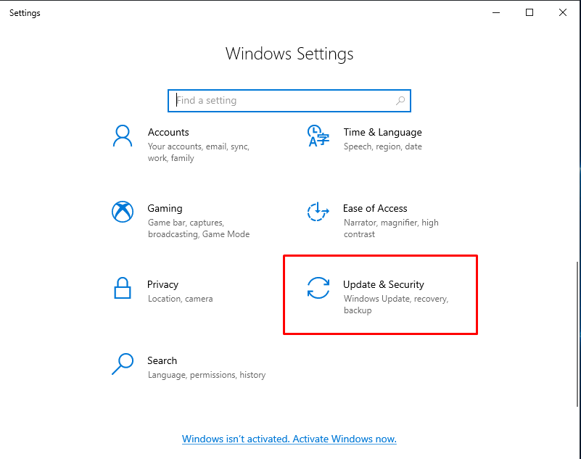

Once here, we will click “Recovery” and, in “Advance Settings”, click “Restart now”.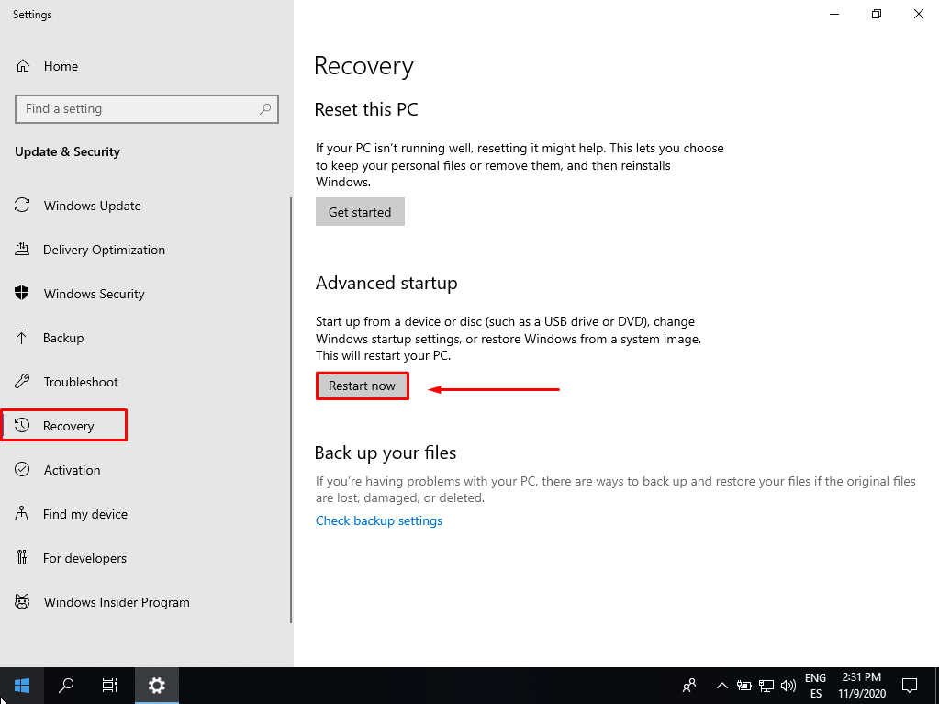

After clicking there, the Windows 10 bootloader will appear again. Then we will click “Use another operating system” and “Change defaults”.

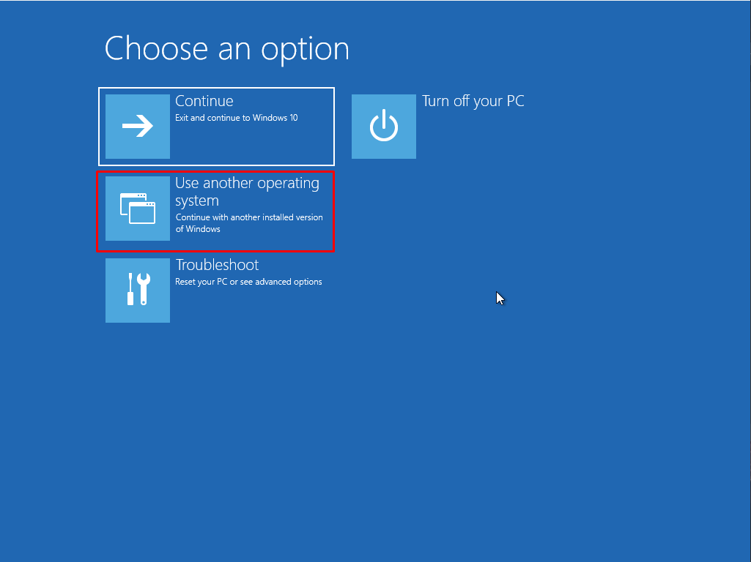

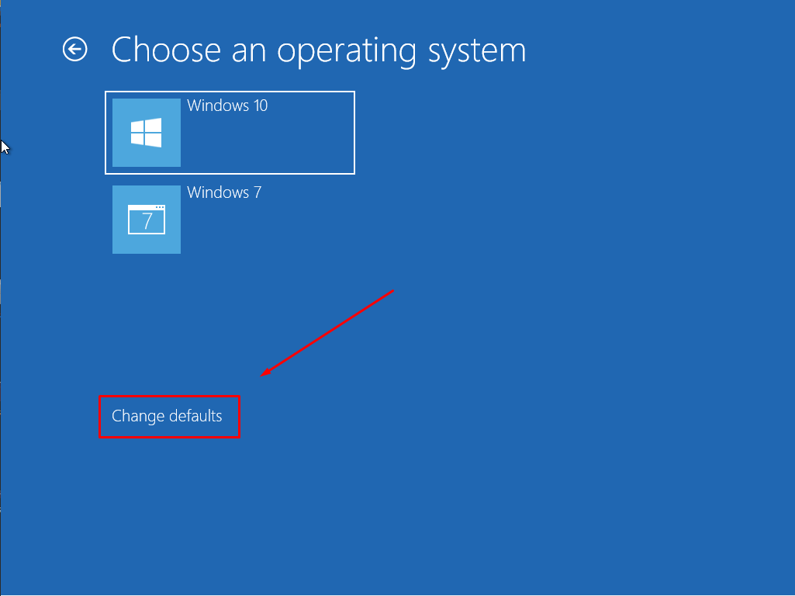

Now we have both options: the time changer and the OS changer. As the exercise asks, we need to click on “Choose a default operating system” and change it to Windows 10.

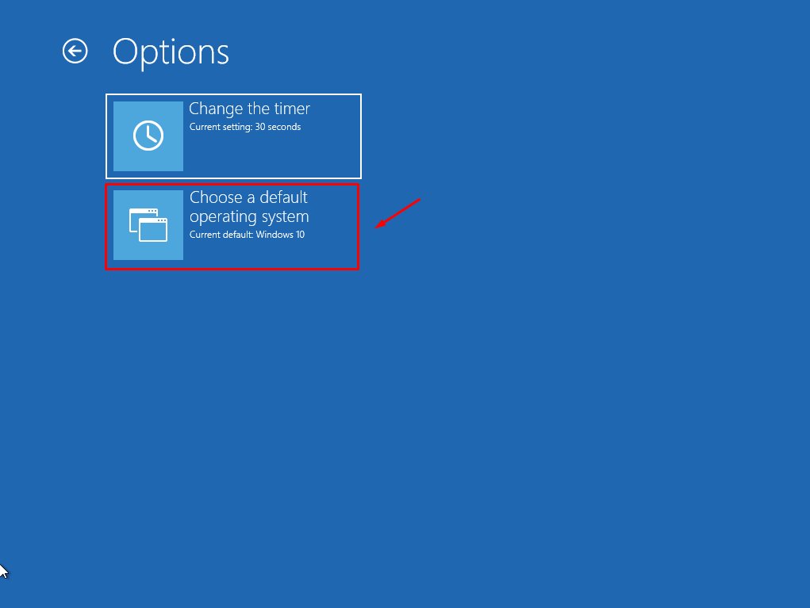

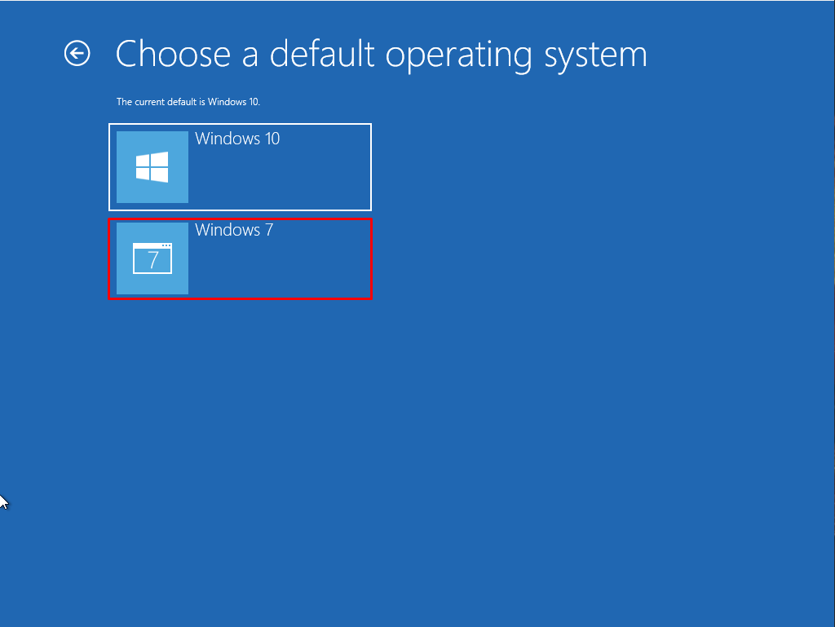

Finally, we need to click on “Change the timer” and select “5 seconds”.

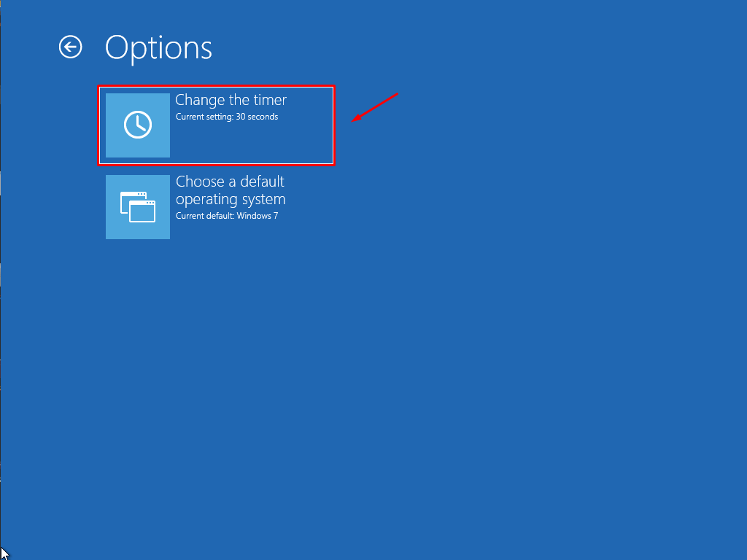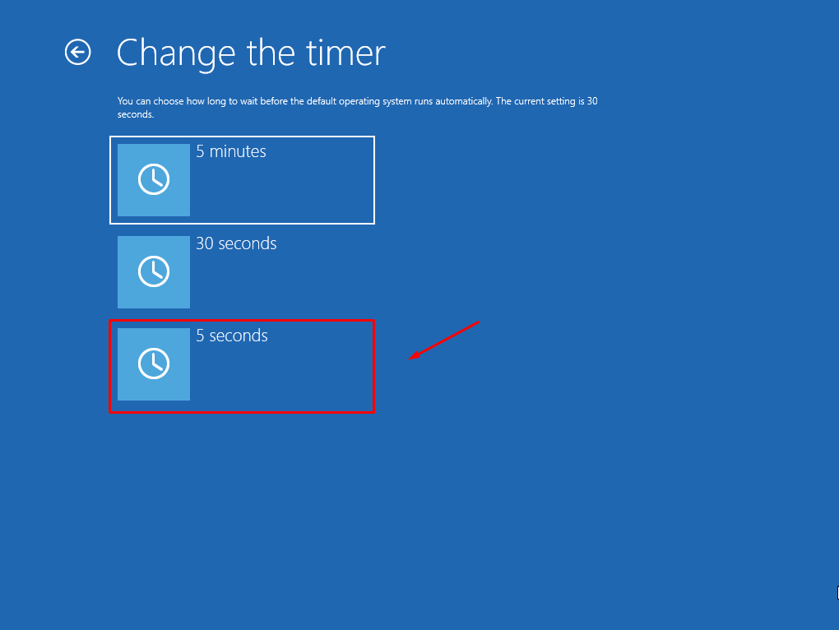

To make sure everything is saved, I would recommend to click the arrow ( ← ) and turn off our machine to restart it manually.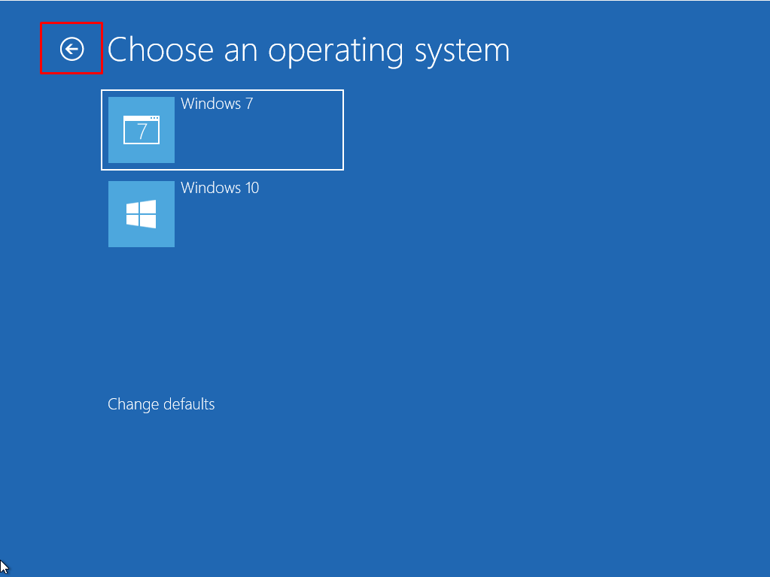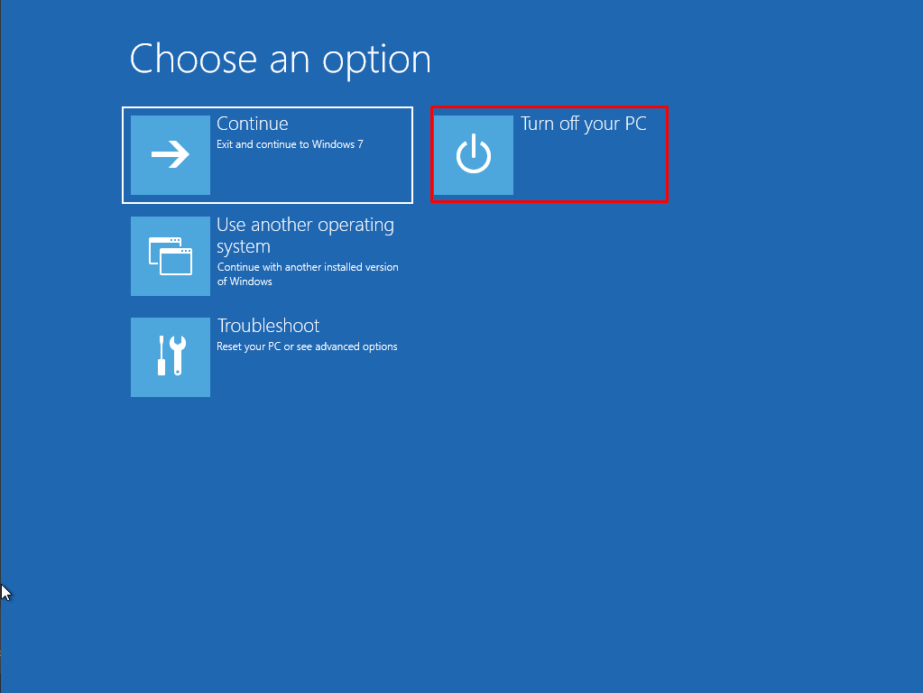

This is what we should see when starting our machine:

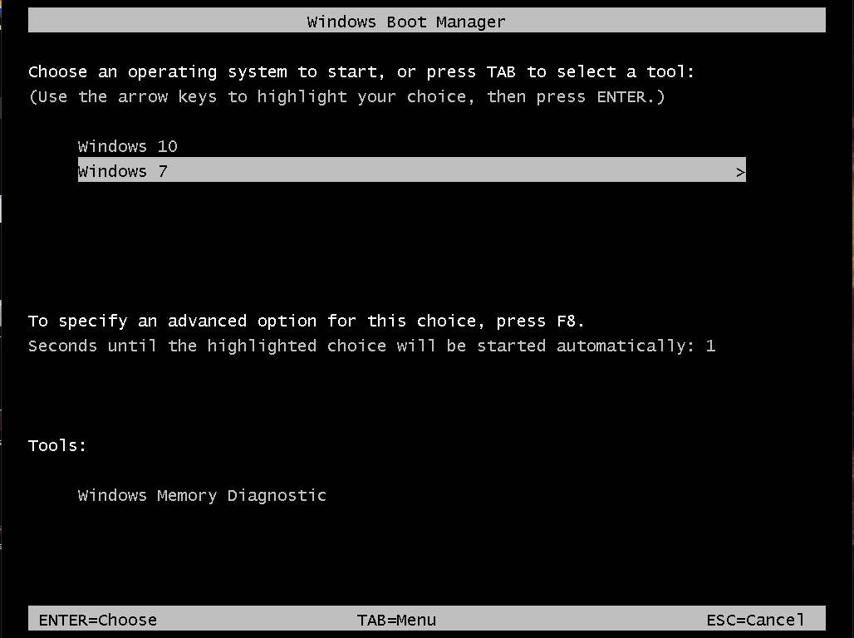

As Windows 7 is now our default operating system, the bootloader that will be displayed is the Windows 7 one.

If you completed all these steps, your configurations are finished!

**ALFREDO PUERTA GALLEGO DW1E**